**Day 5**

**What is AI Project Cycle?**

The AI project cycle refers to the step-by-step process that an organization or a person should follow to develop and deploy an[**artificial intelligence**](https://intellipaat.com/blog/what-is-artificial-intelligence/) (AI) project while solving a problem. It is also called the AI development lifecycle. It provides us with an appropriate framework that helps us to achieve our goal.



**Different Stages of the AI Project Cycle**

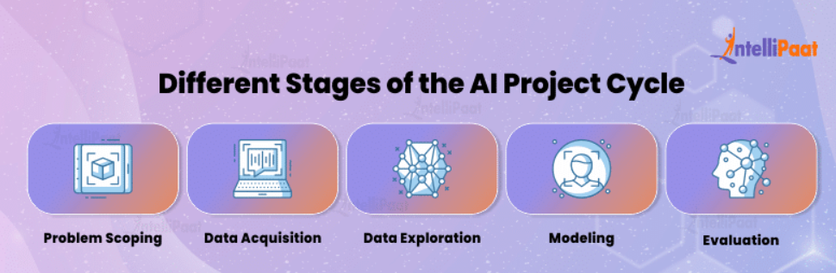

The AI project cycle typically consists of these five stages:

1. Problem Scoping
2. Data Acquisition
3. Data Exploration
4. Modeling
5. Evaluation

Let’s go through all five stages one-by-one.

**Problem Scoping**

Problem scoping is the process of pinpointing a particular issue or opportunity that can be tackled using artificial intelligence (AI). During this phase, we not only identify the problem but also set specific objectives, goals, and criteria for success. However, scoping a problem is no simple task. It requires a deep understanding of the issue so that we can work effectively and solve [**problem-solving**](https://intellipaat.com/blog/what-is-problem-solving/#:~:text=Problem%2DSolving%20aims%20to%20identify,with%20innovative%20solutions%20to%20challenges.).

To achieve this, we rely on an approach called the 4Ws problem canvas, which helps us gain a clearer and more defined understanding of the problem we’re dealing with.

**The 4Ws Problem Canvas**

The 4Ws problem canvas helps in recognizing the key elements related to the problem. The 4Ws are as follows:

1. Who
2. What
3. Where
4. Why

Let’s see what these mean:

**1. Who:** The “Who” section helps us examine the individuals affected by the issue. It’s essential to pinpoint the key people involved and gather information about them. These key people are often named stakeholders, and they are the ones impacted by the problem and could benefit from a potential solution.

**2. What:**The “What” section is all about understanding the problem thoroughly. Here, we dig into the available information. This is done for the following purposes:

* Identify the characteristics of the issue
* Comprehend what makes it a problem
* Collect supporting evidence to prove that the problem exists

This evidence can come from various sources like newspaper articles, media reports, official announcements, and more.

**3. Where:**Once we have identified the stakeholders and the nature of the problem, we must investigate where and when it occurs. This information will give us a better understanding of the situation and help us identify patterns and trends.

**4. Why:** After we’ve gathered all the essential information about the problem, it’s essential to determine who will benefit from solving it, what exactly needs to be fixed, and where the solution will be put into action. These three elements lay the roots for understanding why we should address this problem.

**Data Acquisition**

This is the second phase of the AI project cycle, which is focused on obtaining the necessary data for the project. While developing an AI system for predictive purposes, it’s essential to begin by training it with relevant data.

Suppose you want to build a system that predicts how much an employee will earn in the future based on what they’ve earned in the past. To do this, you feed the system the historical salary information. We call this historical salary data “training data”, while the dataset used for future salary predictions is called testing data.

Here, the specific kinds of information you want to collect are called data features. In our previous example, these data features could be things like the employee’s salary amount, the percentage of salary increase they received, the time between salary raises, any bonuses they’ve earned, and more.

There are various methods to gather this data, such as follows:

**1. Surveys**

**2. Web Scraping**

**3. Sensors**

**4. Cameras**

**5. Observations**

**6. API (Application Programming Interface)**

One of the most dependable and trustworthy sources for data is government-hosted open-access websites. Examples of such government portals include data.gov.in and india.gov.in.

**Data Exploration**

Data is a complicated thing, often just a bunch of numbers. But to make sense of it, we need to find the hidden patterns. That’s where data visualization comes in. It’s all about turning those numbers into pictures that are easy for people to understand. This allows you to include:

* **Spotting Trends and Patterns:** When you look at a chart or graph, you can quickly see if something is going up, down, or staying the same. That helps you spot trends and patterns in the data.
* **Choosing the Right Tools:** Data visualization helps you decide which method or model is best for further analysis. It’s like picking the right tool for the job.
* **Sharing Insights:** Once you’ve figured things out, you can show your findings to others. A picture is worth a thousand words, as they say. Visualizing data makes it easier to explain your insights to others.

To visualize data, you can use various types of visuals like bar graphs, histograms, line charts, and pie charts. These visuals make the data more approachable and understandable.

**Modeling**

In the AI project cycle, modeling is a critical step in simplifying complex data for computers to process and make predictions. At the start, data is usually presented in charts or graphs to help people spot patterns. But, for AI systems to work, we need to convert this data into a basic form that computers can grasp that is binary (0s and 1s).

Modeling in AI essentially involves creating a mathematical framework that defines the relationships between different data points or parameters. Think of it like teaching a computer to recognize patterns or make decisions. These models can be as simple as linear equations or incredibly complex [**neural networks**](https://intellipaat.com/blog/tutorial/machine-learning-tutorial/neural-network-tutorial/), depending on the task at hand.

After the computer learns these rules from historical data, it can use them to make predictions or decisions about new data.

**Evaluation**

Now, we are at the last stage of the AI project cycle. Once you’ve created and trained a model, it’s crucial to thoroughly test it to evaluate how well it performs. To do this, we use a separate dataset called testing data. The model’s efficiency is then evaluated based on the following criteria:

* **Precision**: Precision helps us understand how good the model is at avoiding false alarms. It measures the proportion of correctly predicted positive cases out of all the positive predictions the model made.
* **Accuracy**: Accuracy gives us an overall view of the model’s correctness. It calculates the percentage of correct predictions (both true positives and true negatives) over the entire dataset.
* **F1 Score**: The F1 score is a special metric that combines precision and recall. It’s especially helpful when you’re dealing with datasets where one class greatly outnumbers the other. This metric balances the trade-off between false positives and false negatives.
* **Recall**: Recall, also known as sensitivity or the true positive rate, tells us how well the model can correctly identify all positive instances in the dataset. It shows how effectively the model avoids missing positive cases.

Now that we have gone through all the five stages of the AI project cycle, let’s have a look at why we need an AI project cycle.

**What is the Need of an AI Project Cycle?**

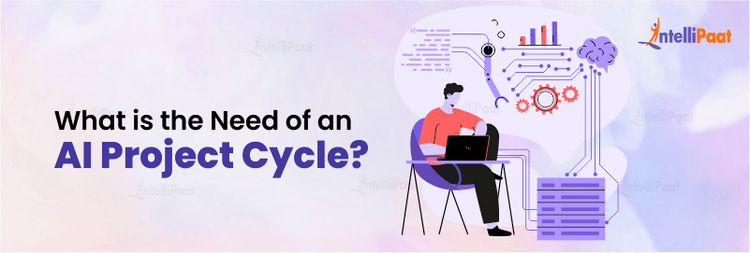

The project cycle is a systematic process which consists of planning, coordination, organization, and the complete development of a project, with the ultimate goal of achieving predefined objectives. Just as we naturally make plans to get things done, the AI project cycle gives us a structured way to work on AI projects.

* The main goal of the AI project cycle is to make developing AI projects easier to understand and manage.
* It breaks the process into clear phases, making each step more specific. This approach helps us get the best results.
* It primarily consists of stages that describe the entire development process into clear and specific steps.

**Conclusion**

In a nutshell, the AI project cycle is a structured roadmap for developing and deploying artificial intelligence projects to solve real-world problems. It guides organizations and individuals through a structured process that includes problem scoping, data acquisition, data exploration, modeling, and evaluation. This systematic approach helps define objectives, collect relevant data, uncover hidden insights, create models for AI systems, and assess their performance. By following the AI project cycle, stakeholders can enhance the efficiency and effectiveness of their AI initiatives.